**BPP Business School**

**Coursework Cover Sheet**

Please use this document as the cover sheet of for the 1st page of your assessment. Please complete the below table – the grey columns

|  |  |
| --- | --- |
| Module Name | Big Data and Cloud Computing |
| Programme Name | Management with Data Analytics |
| Student Reference Number (SRN) | BP0293328 |
| Assessment Title | FarmFlow FarmOptix Cloud-based Architecture Project |

Please complete the yellow sections in the below declaration:

|  |  |  |  |  |
| --- | --- | --- | --- | --- |
| Declaration of Original Work:  I hereby declare that I have read and understood BPP’s regulations on plagiarism and that this is my original work researched undertaken completed and submitted in accordance with the requirements of BPP School of Business and Technology.  The word count excluding contents table bibliography and appendices is __2500____ words. | | | | |
| Student Reference Number: _ | ____BP0293328_____ | Date: | _22—10-2024_____ |  |

By submitting this course work you agree to all rules and regulations of BPP regarding assessments and awards for programmes.

Please note that by submitting this assessment you are declaring that you are fit to sit this assessment.

BPP University reserves the right to use all submitted work for educational purposes and may request that work be published for a wider audience.

BDC CW3(S)



MSc Management with Data Analytics

Big Data and Cloud Computing

Coursework Assessment Brief

BDC CW3(S)

Submission mode: Turnitin online access

BDC CW3(S)

Contents

**Introduction** 4

**Task 1: Big Data Requirements & Storage Solutions** 4

Big Data Requirements 4

**Evaluation of Storage Solutions** 5

**Task 2: System Architecture** 7

**Task 3: Project Risks & Issues** 8

**Identification of Risks and Issues** 8

**Mitigation Strategies** 9

**Conclusion** 9

**References** 10

# **Introduction**

AgriPulse an established agricultural technology company seeks to leverage big data and cloud computing to drive its CropFusion project aiming to expand its capabilities in precision agriculture. This initiative focuses on utilizing Internet of Things (IoT) technologies to collect real-time data from various agricultural settings facilitating improved decision-making processes to optimize crop yields and mitigate risks associated with environmental factors. The project's success hinges on integrating advanced data analytics to process and analyze the vast amounts of data generated which will empower AgriPulse to deliver actionable insights to farmers globally (Jas et al. 2021).This report outlines a proposed cloud-based architecture to address the big data needs of the CropFusion project evaluates multiple cloud storage solutions to identify the most effective for managing large datasets and discusses potential deployment challenges with corresponding mitigation strategies. Assumptions include the availability of cutting-edge IoT devices on farms and the capability of cloud infrastructures to efficiently process and store substantial data volumes. The structure of the report will cover three main areas: specifying the big data requirements of AgriPulse reviewing applicable cloud storage solutions and detailing the architectural design for the system implementation.

# **Task 1: Big Data Requirements & Storage Solutions**

## Big Data Requirements

For the CropFusion project by AgriPulse the big data requirements are pivotal in determining the success of their cloud-based agricultural solutions. As outlined in the model of the 4 V's of big data these requirements revolve around volume velocity variety and veracity. With each playing a crucial role in handling and processing agricultural data efficiently.

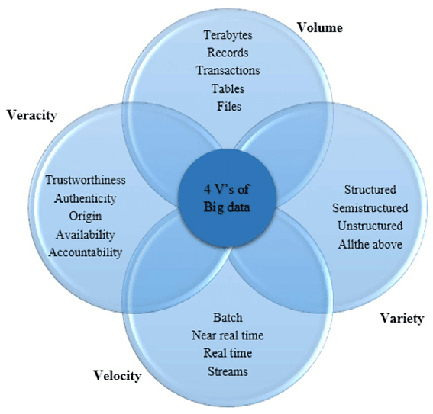

**Figure 1 4V's Model**

The project expects to handle vast amounts of data generated from multiple IoT devices installed across various farming locations. This includes data from soil moisture sensors weather stations and aerial imagery from drones which cumulatively produce terabytes of data. Effective storage and processing capabilities are required to manage this volume ensuring that the cloud infrastructure can scale accordingly to meet data demands (Jas et al. 2021). The data flow will be continuous necessitating the infrastructure to support near-real-time processing to enable prompt decision-making. The velocity of data entails not only the speed of data ingress but also the capability to process and analyze this data swiftly to provide timely insights to farmers which is critical during planting and harvesting seasons when conditions can change rapidly.

**Variety**: Data collected will be of various types and formats including structured data from databases semi-structured data from sensors and unstructured data such as images and videos from drones. This variety requires a flexible data management system that can integrate and homogenize different data types for seamless analysis and storage.

**Veracity**: The accuracy and reliability of data are paramount as the insights derived from this data directly influence farming decisions. Data must be cleansed and validated to ensure it is trustworthy and precise. This includes verifying the authenticity and accountability of data sources particularly when integrating data from external partners like CropSight Analytics and HarvestNex which provide specialized IoT devices for detailed monitoring (Jas et al. 2021).

Addressing these four V's AgriPulse can build a robust framework for the CropFusion project that not only supports the scale and complexity of agricultural data but also enhances the decision-making process through reliable and timely insights thereby optimizing crop yields and minimizing losses due to environmental impacts.

# **Evaluation of Storage Solutions**

When evaluating cloud-based storage solutions for the CropFusion project it's essential to consider various platforms that offer distinct capabilities scalability cost-efficiency and suitability to meet the demanding data requirements of modern agriculture. Prominent cloud providers such as Amazon Web Services (AWS) Google Cloud Platform (GCP) and Microsoft Azure are at the forefront of offering scalable and robust data storage solutions.

**Amazon Web Services (AWS)**: AWS provides a comprehensive suite of cloud storage services that include Amazon S3 for scalable object storage Amazon EBS for block storage and Amazon Glacier for long-term archival storage. AWS is renowned for its high durability availability and scalability which make it an attractive option for agricultural data management. The platform supports big data analytics tools that can handle the vast amounts of data generated by IoT devices in agriculture. AWS also offers specific IoT services like AWS IoT Core which allows easy and secure interactions between connected devices and the cloud. This integration facilitates real-time data processing and storage crucial for monitoring and decision-making in agriculture (Khairan et al. 2021).

**Google Cloud Platform (GCP)**: GCP offers high-performance and scalable storage solutions such as Google Cloud Storage which is well-suited for storing large datasets including unstructured data like images and videos from drones used in agricultural monitoring. GCP's BigQuery and Google Cloud Bigtable provide powerful data warehousing and NoSQL database services respectively ideal for handling the variety and velocity of data in smart farming. Google's strong points include its deep learning and machine learning capabilities integrated within the cloud infrastructure which can be leveraged to enhance predictive analytics in agriculture thus supporting crop yield optimization and risk management.

**Microsoft Azure**: Azure provides versatile storage options such as Azure Blob Storage for large amounts of unstructured data and Azure Table Storage for NoSQL data. Azure is particularly noted for its hybrid cloud capabilities which is a critical feature for agricultural enterprises that may require on-premises computations coupled with cloud storage. Azure's IoT Hub supports the management of IoT device communications and data ensuring seamless data flow from field devices to the cloud. Additionally Azure offers AI tools and services that integrate with its storage solutions enabling advanced scenarios like predictive maintenance of farming equipment and climate impact modeling.

In terms of scalability all three platforms offer the ability to scale up or down based on the needs of the project which is essential during different agricultural seasons when data volume can fluctuate significantly. Cost-wise while initial investments might be substantial the long-term benefits of cloud storage—such as reduced need for local storage infrastructure and enhanced data analytics capabilities—justify the expense. Each platform also provides various pricing models that can be tailored to specific usage patterns typical in agriculture such as pay-as-you-go and reserved instance pricing which can help manage costs effectively.

Finally the choice of cloud provider may depend on specific project requirements such as geographical data residency requirements specific integration needs with existing agricultural tech platforms or the availability of specialized services. The environmental and operational data collected in the CropFusion project can be optimally managed with robust cloud storage solutions that offer not only storage but also sophisticated data processing capabilities thus enabling more informed and timely agricultural decisions (Rajab et al. 2021).

# **Task 2: System Architecture**

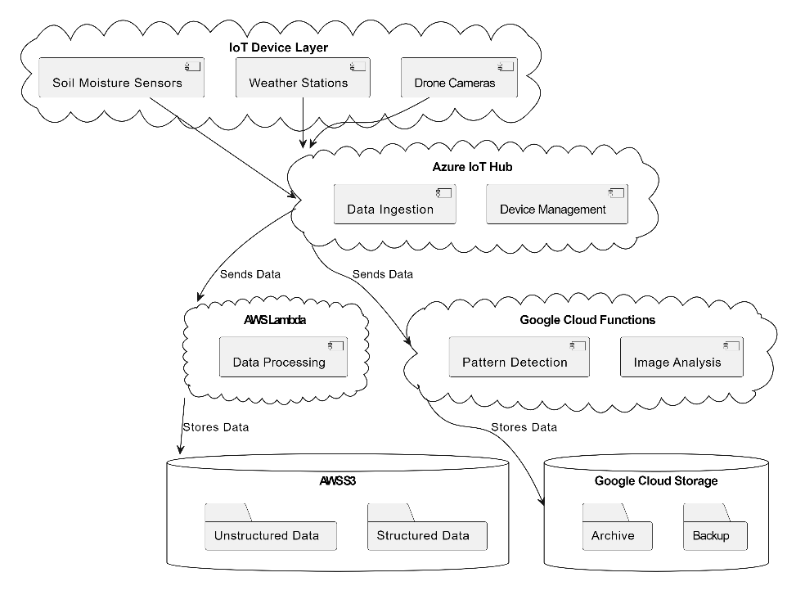

**Figure 2 Proposed Architecture**

The proposed cloud-based architecture for the CropFusion project leverages a combination of IoT integration cloud processing services and advanced storage solutions to meet the complex demands of modern agriculture. At the core of this architecture IoT devices such as soil moisture sensors weather stations and drone cameras are deployed across the farm to gather diverse data types. These devices are directly connected to Azure IoT Hub which serves as the central node for device management and data ingestion. This setup ensures real-time data flow from the field to the cloud where immediate data processing is crucial for timely agricultural decisions (Khairan et al. 2021). Upon data collection the architecture utilizes cloud processing capabilities provided by AWS Lambda and Google Cloud Functions. These services are chosen for their ability to scale automatically handling varying loads of data ingestion without the need for manual intervention. AWS Lambda is particularly beneficial for executing code in response to triggers from the Azure IoT Hub thus enabling real-time analytics and immediate response to data received. Google Cloud Functions complements this by providing a highly scalable and cost-effective environment for running event-driven HTTP and background tasks which are essential for data processing tasks such as image analysis from drones and pattern detection in weather changes. The processed data is then stored in scalable cloud storage solutions like AWS S3 and Google Cloud Storage which offer robust durability and data availability ensuring that data is securely stored and persistently available for further analysis and historical record-keeping. This integration not only supports the high volume velocity and variety of agricultural data but also ensures veracity by providing reliable and consistent data storage options that are crucial for accurate agricultural forecasting and planning (Rajab et al. 2021).

Through this architecture AgriPulse can achieve a seamless flow of data from collection to actionable insights. The use of Azure IoT Hub for device management and data ingestion ensures that all devices are properly authenticated and managed reducing the risk of data breaches and ensuring data integrity. Meanwhile the combination of AWS Lambda and Google Cloud Functions for data processing allows for the implementation of complex algorithms and machine learning models that can predict crop yields detect potential diseases and suggest optimal farming practices based on real-time data. Finally, the use of AWS S3 and Google Cloud Storage ensures that all processed data is stored securely and is easily accessible for both real-time decisions and long-term strategic planning thereby meeting the project’s requirements for a scalable secure and efficient data architecture that supports the advanced needs of smart agriculture.

# **Task 3: Project Risks & Issues**

## **Identification of Risks and Issues**

In the deployment of the CropFusion project several critical risks span across deployment operational and security aspects. These risks are tabulated below along with their potential impact on the project.

|  |  |  |  |  |
| --- | --- | --- | --- | --- |
| **Risk Category** | **Specific Risk** | **Potential Impact** | **Likelihood** | **Mitigation Priority** |
| Deployment | Integration difficulties between IoT devices and cloud platforms | Delays in project timelines increased costs | High | High |
| Operational | Cloud service downtime or inefficiencies | Loss of real-time data processing impacting decision-making | Medium | High |
| Security | Data breaches due to cyber-attacks on IoT devices | Compromise of sensitive agricultural data loss of farmer trust | High | High |
| Security | Physical tampering of remote IoT devices | Data manipulation or loss system disruption | Medium | Medium |
| Operational | Scalability issues during peak data loads | Inability to process data efficiently during critical times | High | High |

These risks are intricately linked with the potential to significantly derail project outcomes. For instance integration difficulties (deployment risk) can lead to ineffective data collection and analysis directly affecting the agricultural insights provided to farmers. Similarly operational risks like cloud service downtime can result in delays in processing environmental data crucial for timely agricultural responses thereby impacting crop yields and operational efficiency. Security risks are particularly concerning as data breaches could expose sensitive agricultural data undermining the confidentiality and integrity of farmer information and leading to significant reputational damage (Khairan et al. 2021; Rajab et al. 2021).

# **Mitigation Strategies**

Effective mitigation strategies are essential to address the identified risks ensuring the robustness and reliability of the CropFusion project:

* **Integration Testing**: Conduct thorough compatibility and integration testing before full-scale deployment to address deployment risks.
* **Redundancy and Failover Systems**: Implement redundant storage and processing capabilities along with failover systems to mitigate the impact of cloud service downtime.
* **Enhanced Security Protocols**: Employ state-of-the-art cybersecurity measures including advanced encryption continuous monitoring and intrusion detection systems to safeguard against cyber threats.
* **Physical Security Measures**: Install physical security measures at IoT device locations to prevent tampering and theft.
* **Scalability Planning**: Utilize elastic cloud services that automatically adjust to varying data loads ensuring efficient data processing during peak periods.

By implementing these strategies AgriPulse can not only minimize the risks associated with the CropFusion project but also enhance its overall success and sustainability. These strategies should be continuously reviewed and adapted to evolving technological landscapes and emerging threats to maintain the integrity and efficiency of the system.

# **Conclusion**

The CropFusion project exemplifies a strategic integration of IoT and cloud technologies to enhance agricultural efficiency and decision-making. By identifying and meticulously planning against potential deployment operational and security risks AgriPulse ensures the project's robustness and reliability. The proposed cloud-based architecture promises scalability and real-time data processing capabilities critical for managing the diverse and voluminous data generated in modern farming. Moreover, the prioritization of mitigation strategies such as advanced security measures and scalable cloud services highlights the project's commitment to sustainable and technologically advanced agriculture. Overall CropFusion stands as a model for future agri-tech initiatives aiming to leverage big data for enhanced agricultural outcomes.

# **References**

1. **Boudriki Semlali, A. and El Amrani, K.**, 2022. Data Analytics for Crop Management: A Big Data View. *Journal of Big Data*, [online] Available at: <https://journalofbigdata.springeropen.com> [Accessed 22 Oct. 2024].
2. **Deeken, H. et al.**, 2021. Big Data and Precision Agriculture: A Novel Spatio-Temporal Semantic IoT Data Management Framework for Improved Interoperability. *Journal of Big Data*, [online] Available at: <https://journalofbigdata.springeropen.com> [Accessed 22 Oct. 2024].
3. **Delgado, J.A. et al.**, 2011. Strategies for Nitrogen Management in Agricultural Systems: Implications for Water Quality and Greenhouse Gas Emissions. *Critical Reviews in Environmental Science and Technology*, 41(6), pp. 555-611. Available at: <https://www.tandfonline.com> [Accessed 22 Oct. 2024].
4. **Khairan, R., Al Reshan, M.S. and Alkinani, M.**, 2021. Smart Agriculture Cloud Using AI-Based Techniques. *Energies*, 14(16), p.5129. Available at: <https://doi.org/10.3390/en14165129> [Accessed 22 Oct. 2024].
5. **Pierce, F. and Nowak, P.**, 1999. Aspects of Precision Agriculture. *Advances in Agronomy*, vol. 67, pp. 1-85. Available at: https://www.elsevier.com/books [Accessed 22 Oct. 2024].
6. **Talavera, J.M. et al.**, 2017. IoT Applications in Agricultural and Environmental Fields. *Computers and Electronics in Agriculture*, vol. 142, pp. 283-297. doi: 10.1016/j.compag.2017.09.015.
7. **Wang, X.**, 2021. Internet of Things for the Future of Smart Agriculture: A Comprehensive Survey of Emerging Technologies. *Journal of Advanced Research*, [online] Available at: <https://www.ieee-jas.net> [Accessed 22 Oct. 2024].
8. **Wisnubhadra, I. et al.**, 2022. Overcoming Data Integration Challenges in Big Data and Cloud Computing. *Journal of Big Data*, [online] Available at: <https://journalofbigdata.springeropen.com> [Accessed 22 Oct. 2024].